SIMATS ENGINEERING
CO3 - ASSESSMENT TOOL - 1: Experiments

COURSE NAME: | Cloud Computing and Big Data Analytics | COURSE CODE: | CSA1522
Name | JANI DILIP
Register Number | 192424314

COURSE OUTCOME COVEREDCO3: Implement cloud-based solutions using cloud storage, web APIs, and platform services for real-world applications. (BL3)
Assessment Tool Weightage: 40%

Dave's Taxonomy: Precision (Level 3)  Question Count: 4 | Total Marks: 40
Duration : 60 Minutes
Code of Conduct
I JANI DILIP (192424314) certify that this submission is my original work and that I have adhered to the guidelines specified for this assessment.
I understand that any violation of academic integrity rules will result in disciplinary action.
Signature of the student: 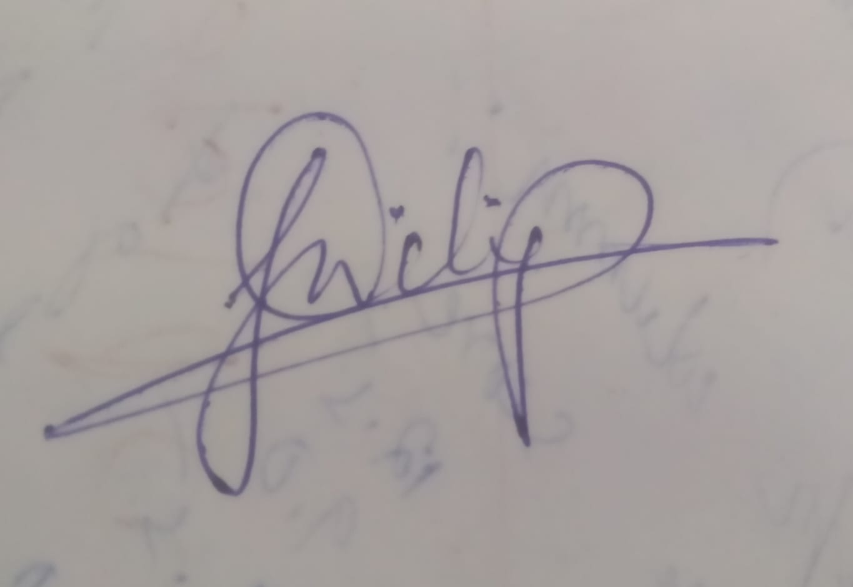

Experiments Rubric
Criteria | Weightage | Level 4 - Exemplary | Level 3 - Proficient | Level 2 - Developing | Level 1 - Beginning
Experimental Design | 25% | Design is systematic and technically strong | Mostly correct design | Basic design with gaps | Poorly designed activity
Use of Tools / Platforms | 20% | Appropriate and effective use of cloud tools | Good tool usage with minor issues | Limited tool usage | Incorrect or missing tool usage
Application of Concepts | 20% | Concepts are applied accurately to practical tasks | Mostly accurate application | Partial application | Weak application
Analysis and Output | 20% | Strong analysis and meaningful outcome interpretation | Good analysis with minor gaps | Basic analysis | Little or no analysis
Documentation | 15% | Clear, structured, and complete documentation | Mostly complete documentation | Partially complete | Poor documentation

Total Marks Awarded:

Assessment Tasks
Experiments

Experiment 1: Create a simple cloud software application for Library book reservation system for SIMATS library using any Cloud Service Provider to demonstrate SaaS include the necessary fields such as Title of the book, author, publications, Year, edition, no of copies, Rack no, status (taken/returned) etc.

Experiment 2: Create a simple cloud software application for Payroll Processing System using any Cloud Service Provider to demonstrate SaaS include the necessary fields such as Name of the employee, experience in present org , over all experience, basic pay, HRA, DA, TA, net pay, gross pay etc.
Experiment 3: Demonstrate virtualization by Installing Type-2 Hypervisor in your device, create and configure VM image with a Host Operating system (Either Windows/Linux). Create a Virtual Machine with 1 CPU, 2GB RAM and 15GB storage disk using a Type 2 Virtualization Software.

Experiment 4: Demonstrate virtualization by Installing Type-2 Hypervisor in your device, create and configure VM image with a Host Operating system (Either Windows/Linux). Create a Cloning of a VM and Test it by loading the Previous Version/Cloned VM

1.AIM: To Create a simple cloud software application for Library book reservation system for SIMATS library using any Cloud Service Provider to demonstrate SaaS

PROCEDURE: step1: Go to zoho.com. step 2: Log into the zoho.com. step 3: Select one application step. step4: Enter application name as library book reservation system. step 5: Created new application as library book reservation system. step 6: Select one form s tep 7: The software has been created.

IMPLEMENTATION:

STEP1: GOTO ZOHO.COM
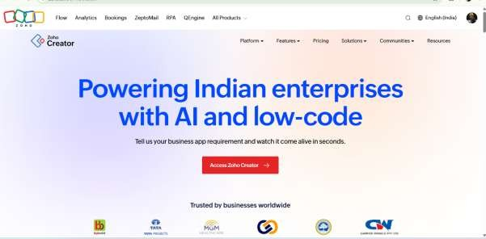

STEP 2: LOGINTOTHE ZOHO.COM

STEP 3: SELECT ONE APPLICATION
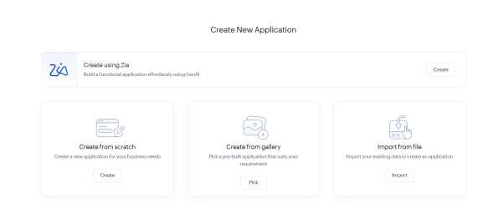
STEP 4: ENTER APPLICATION NAME
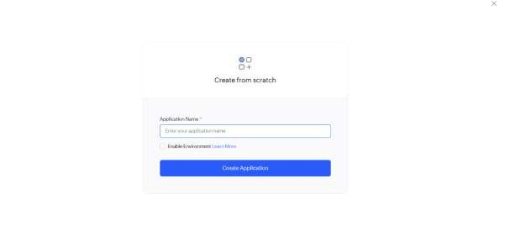
STEP 5: CREATED NEW APPLICATION

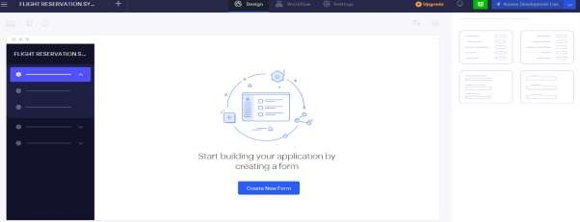

STEP 6: SELECT ONE FORM
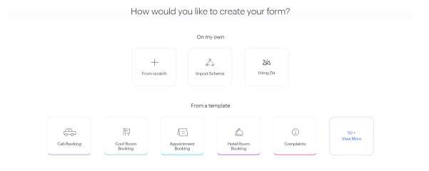
STEP 7: THE SOFTWARE HASE BEEN CREATED.

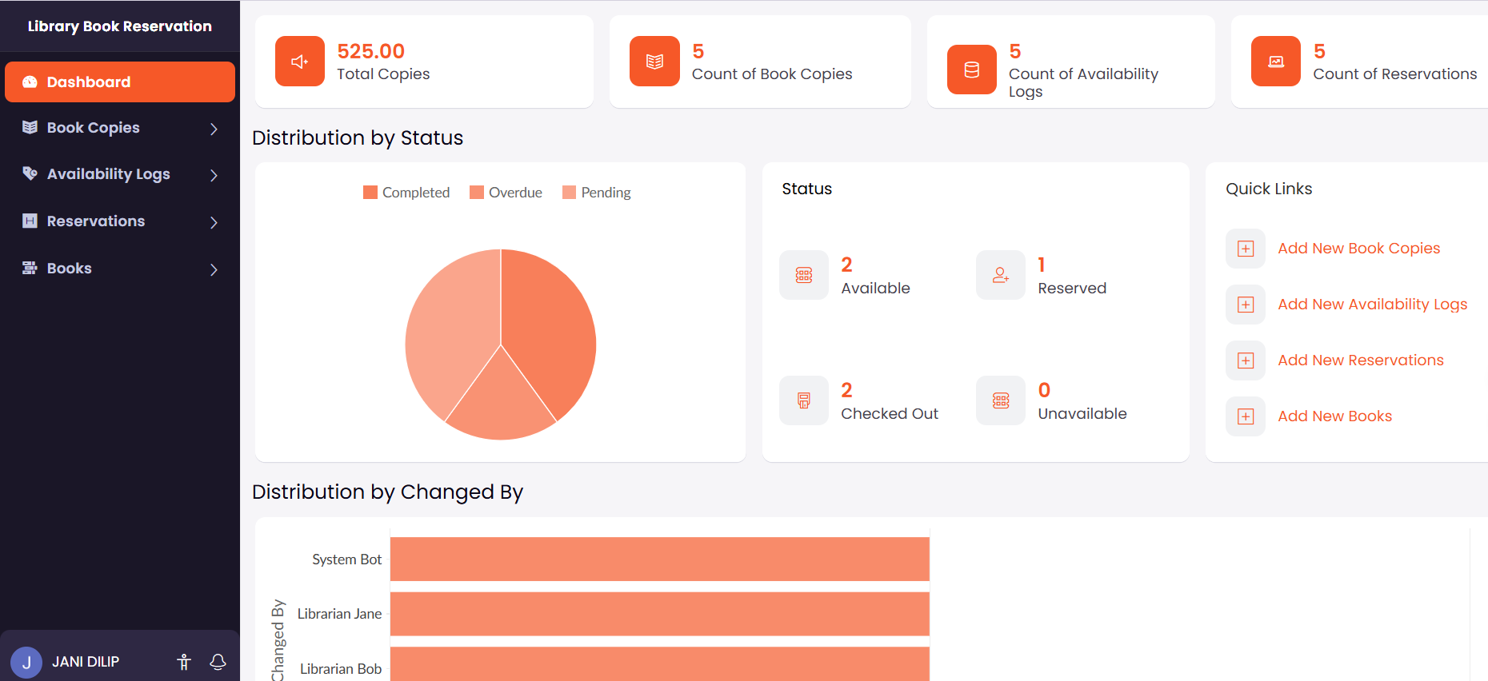
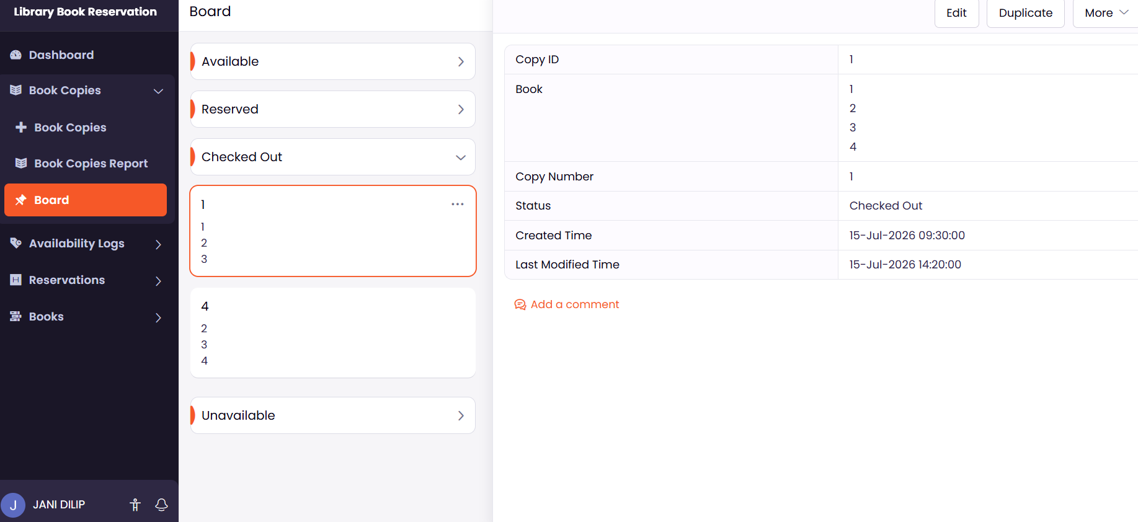

2.AIM:
To create a simple cloud software application for Payroll Processing System using Zoho Creator as a Cloud Service Provider to demonstrate the Software as a Service (SaaS) model.

PROCEDURE:
Step 1: Go to zoho.com.
Step 2: Log in to your Zoho account.
Step 3: Open Zoho Creator from the Zoho applications.
Step 4: Click Create New Application.
Step 5: Enter the application name as Payroll Processing System.
Step 6: Create a new application.
Step 7: Create a new form named Employee Payroll Details.
Step 8: The Payroll Processing System software has been successfully created and deployed on the Zoho cloud platform.

IMPLEMENTATION:

STEP1: GOTO ZOHO.COM


STEP 2: LOGINTOTHE ZOHO.COM

STEP 3: SELECT ONE APPLICATION

STEP 4: ENTER APPLICATION NAME

STEP 5: CREATED NEW APPLICATION
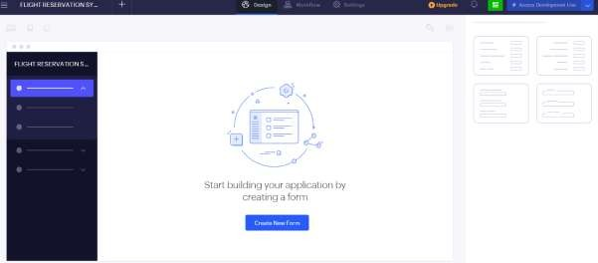

STEP 6: SELECT ONE FORM

STEP 7: THE SOFTWARE HASE BEEN CREATED.
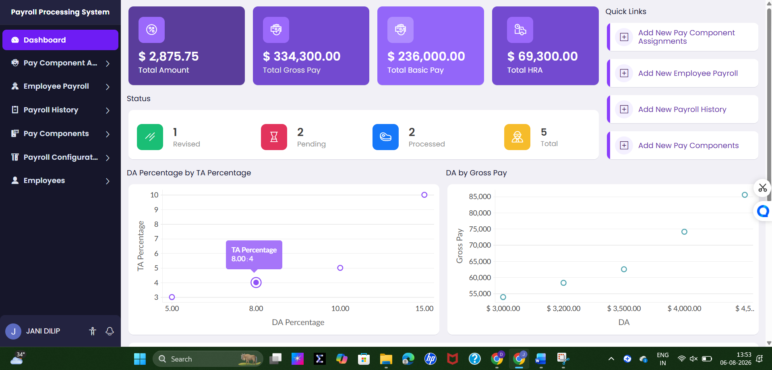
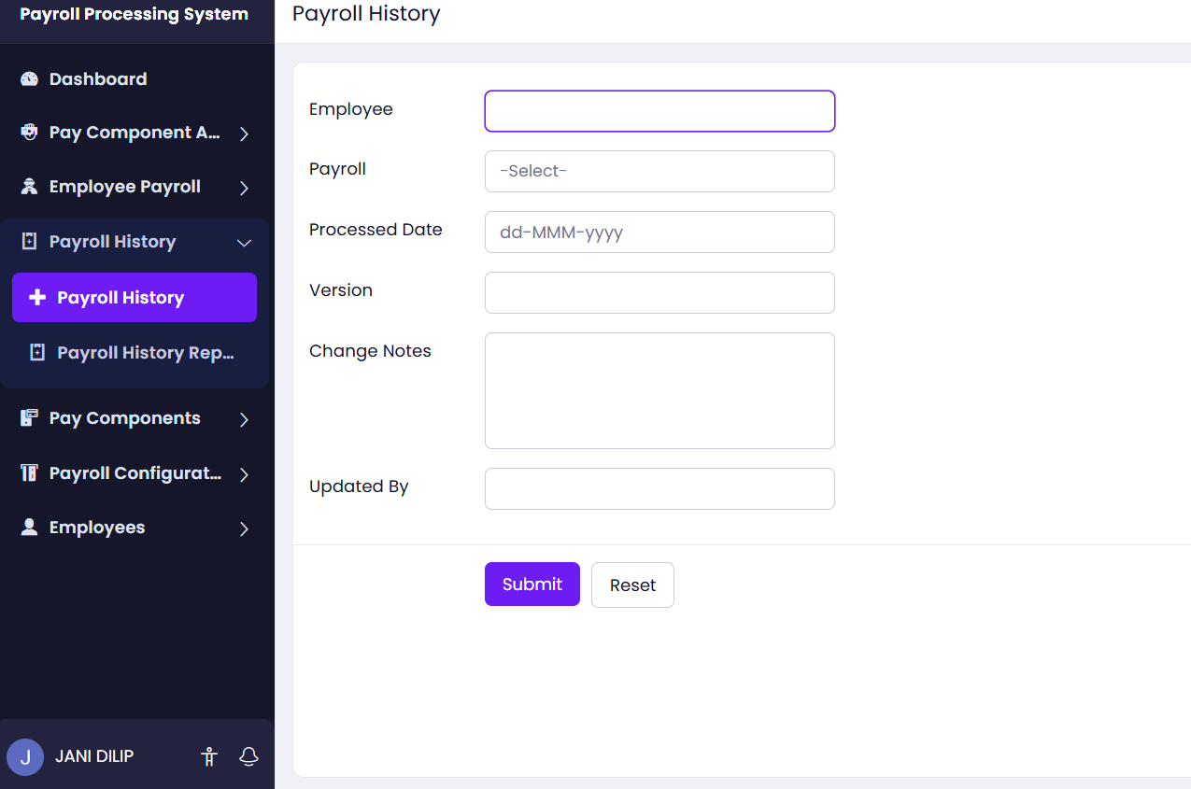

3.Aim:
To create and configure a simple cloud-based application using Zoho Creator with forms, reports, and workflows.
Procedure / Steps
- Open Zoho Creator and sign in with your Zoho account.
- Click Create New Application and select From Scratch.
- Enter the required application name and create the application.
- Create a Form using the drag-and-drop form builder.
- Add required fields such as Name, ID, Email, Phone, and Date.
- Save the form and enter some sample records.
- Create a Report to display and manage the stored records.
- Create a Dashboard to display important information visually.
- Configure a Workflow to automate a required task or action.
- Use Deluge scripting if additional customization is required.
- Test the application by adding, editing, and viewing records.
- Publish or share the application with the required users.
- Thus, the application was successfully created and tested using Zoho Creator.

IMPLEMENTATION:

STEP1: GOTO ZOHO.COM


STEP 2: LOGINTOTHE ZOHO.COM

STEP 3: SELECT ONE APPLICATION

STEP 4: ENTER APPLICATION NAME

STEP 5: CREATED NEW APPLICATION


STEP 6: SELECT ONE FORM

STEP 7: THE SOFTWARE HASE BEEN CREATED.
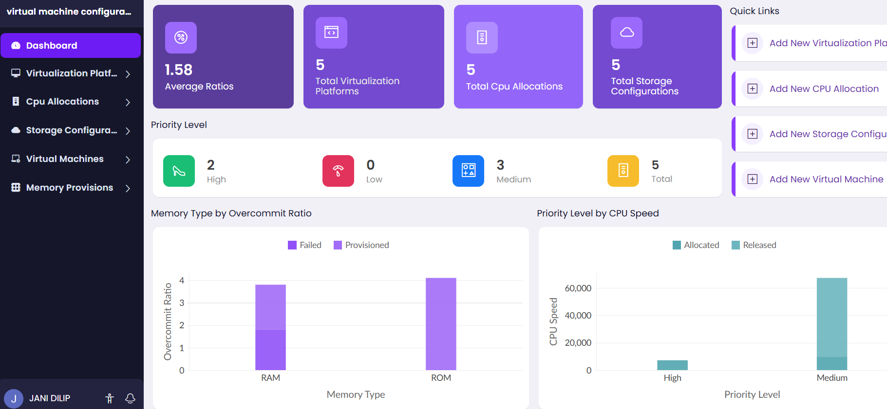

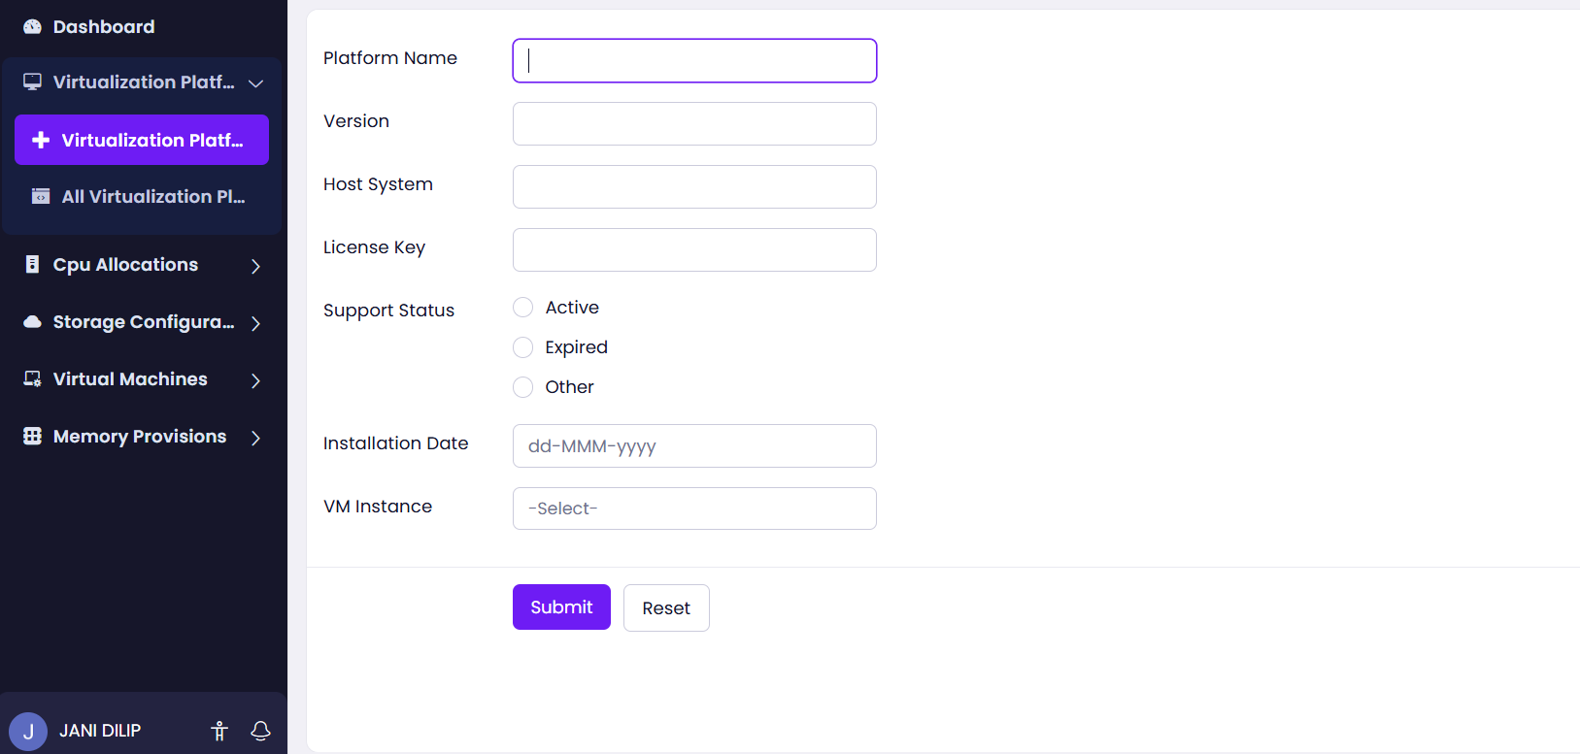

4. Aim
To demonstrate virtualization by installing a Type-2 Hypervisor, creating a Virtual Machine (VM), and installing/configuring a Linux operating system as the guest OS.

Procedure / Steps
- Open Zoho Creator and sign in using your Zoho account.
- Click Create New Application and select From Scratch.
- Enter the application name and click Create.
- Create the required Form using the drag-and-drop form builder.
- Add necessary fields such as Name, ID, Email, Phone, Date, etc.
- Save the form and add sample records.
- Create Reports to display and manage the stored data.
- Create a Dashboard to display important information visually.
- Configure Workflows to automate required actions.
- Use Deluge scripting if any custom functionality is required.
- Test the application by entering and modifying sample data.
- Publish or share the application with the required users.
- Thus, the application was successfully created and tested using Zoho Creator.

IMPLEMENTATION:

STEP1: GOTO ZOHO.COM


STEP 2: LOGINTOTHE ZOHO.COM

STEP 3: SELECT ONE APPLICATION

STEP 4: ENTER APPLICATION NAME

STEP 5: CREATED NEW APPLICATION


STEP 6: SELECT ONE FORM

STEP 7: THE SOFTWARE HASE BEEN CREATED.
